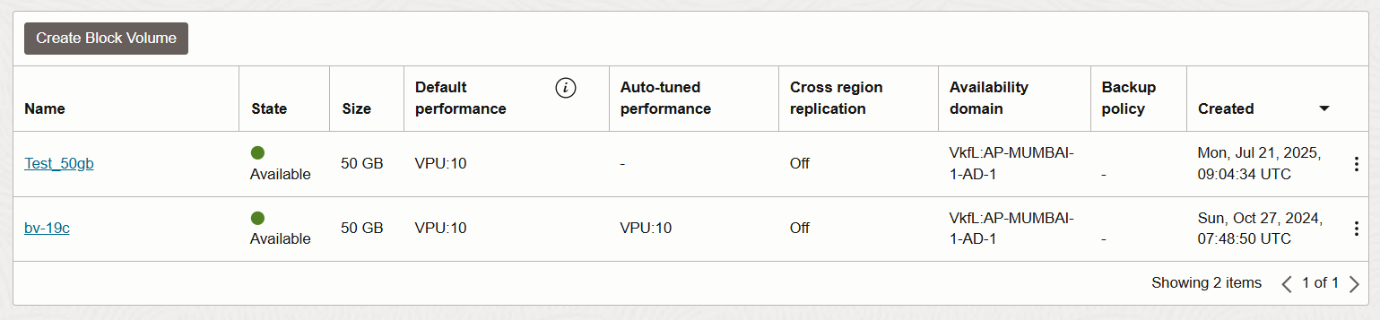1. Go to OCI console --- Block Storage --- Block Volume

2. Create Block Volume

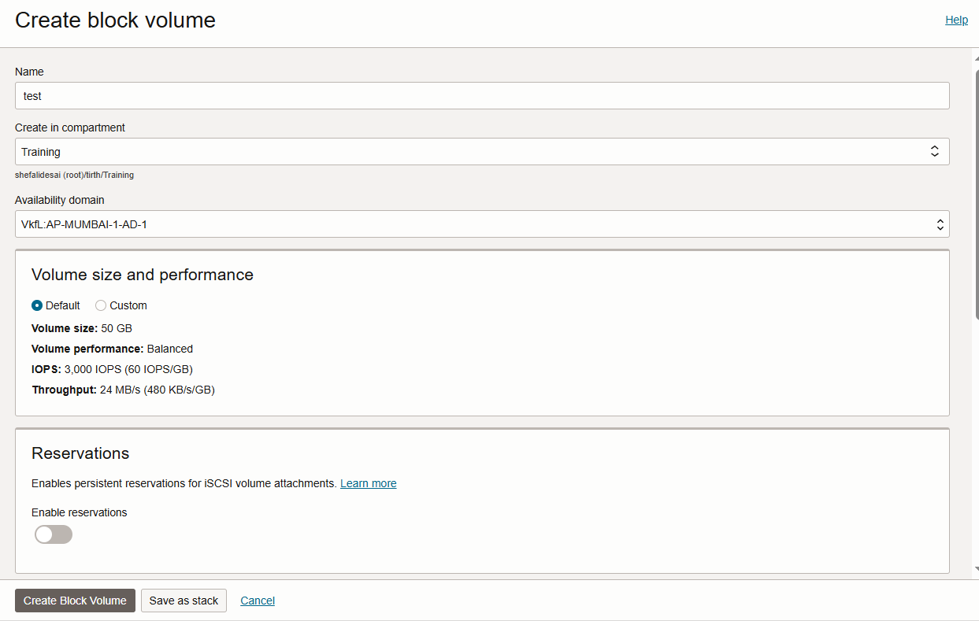 - Enter name, size, backup policy, AD(same as of VM)

3. After it is created go to Attach instance from the block volume

4. Select the instance (if instance is not visible then paste the OCID of the instance) select attachment type iSCSI

5. Connect to VM via SSH (Putty)

6. Login as the root user or use sudo for every command

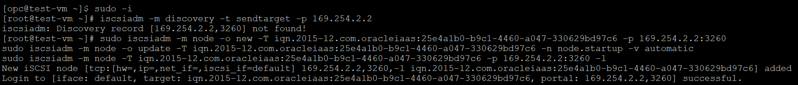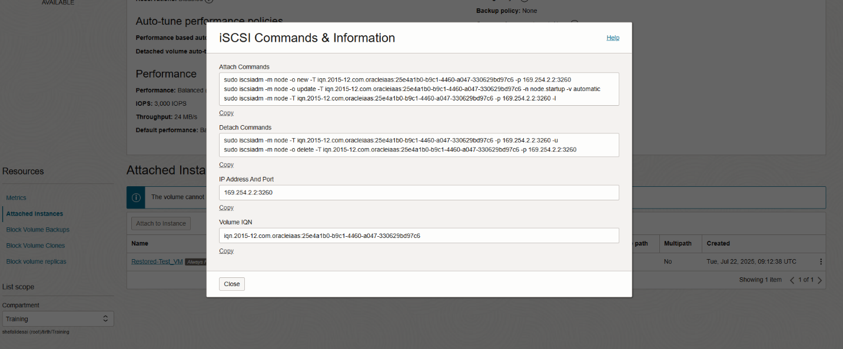7. Discover and connect to iSCSI volume [copy the commands from the console (block volume > attached instance > iSCSI commands & information > copy the attach commands)]

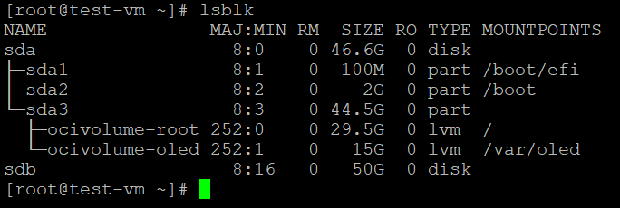8. Find the new disk name (lsblk)

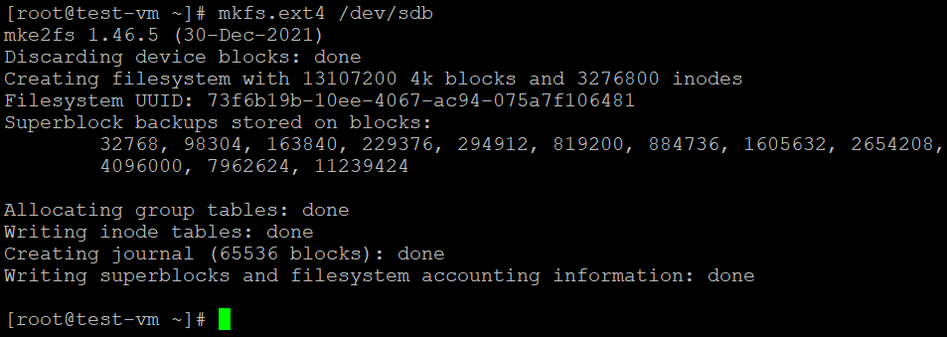9. Format the volume (mkfs .ext4)

10. Create mount directory (mkdir)

D:\BeyonData\OCI tasks\Block Volume\4.PNG

D:\BeyonData\OCI tasks\Block Volume\5.PNG11. Mount to volume (mount)

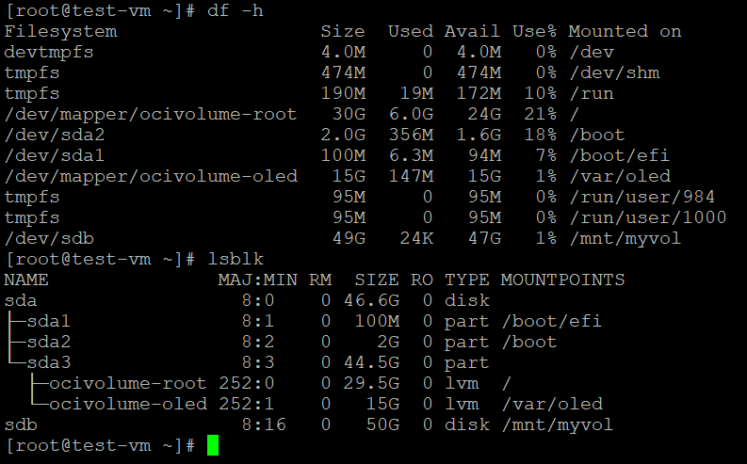12. Verify mount (df -h or lsblk)

🡪Automount on reboot (OPTIONAL)

D:\BeyonData\OCI tasks\Block Volume\7.PNG13. Edit the fstab file (vim /etc/fstab)

D:\BeyonData\OCI tasks\Block Volume\8.PNG14. Add this to the bottom of the file

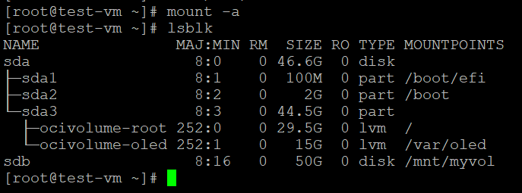15. Run *mount -a* to run the fstab file and recheck the mount through lsblk